Beacon Labs - Lab Report

Name: INSTRUCTOR | Date: (Date of lab completion)
Lab Name: Middlebox Amplification Attack

(Description of the task and how you completed it. Include words and images as necessary)

The objective of this lab

The lab discusses reflection amplification attacks, which were primarily believed to be possible only through the UDP protocol due to the absence of a three-way handshake. However, recent discoveries highlight the vulnerability of the TCP protocol to such attacks, primarily because of middleboxes—often firewalls—that preemptively respond to traffic before servers can. Instead of discarding unrecognized packets, these middleboxes attempt to address requests, sometimes with significantly larger responses than the initial request, potentially leading to amplification attacks. The lab explores various packet structures and their corresponding middlebox responses, aiming to understand and exploit this newfound vulnerability.

Task Set 1
Task 1.1:
Action 1.1.1
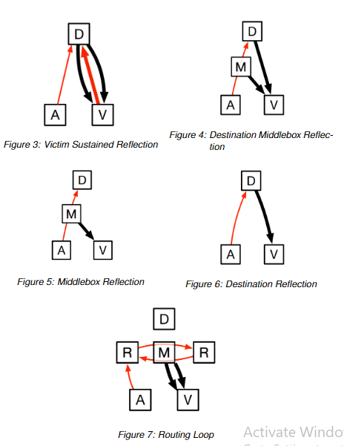
Victim Sustained Reflection:
- Amplification Factor: Multiple packet types
- Attack Method: This type of attack induces a sustained response from the victim to amplify traffic. The attacker sends various packet types to the middlebox while impersonating the victim's IP address, inducing a continuous response from the victim.


Destination & Middlebox Reflection:
- Amplification Factor: RST
- Attack Method: The attacker sends an RST packet to the middlebox while impersonating the victim's IP address. The middlebox responds with an RST packet to the victim. Again, this process amplifies the traffic.


Middlebox Reflection:
- Amplification Factor: Data
-Attack Method: The attacker sends a data packet to the middlebox while impersonating the victim's IP address. The middlebox responds with a data packet to the victim. Traffic is amplified during this process as well.

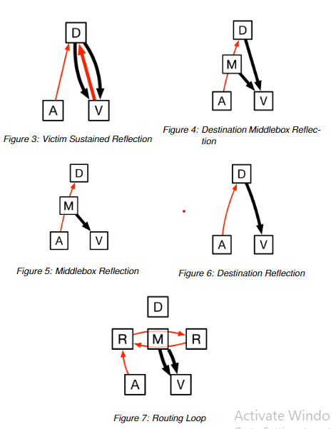
Destination Reflection:
- Amplification Factor: SYN
- Attack Method: The attacker sends a SYN packet to the middlebox while impersonating the victim's IP address. The middlebox responds with a SYN-ACK packet to the victim. This process amplifies the traffic.


Routing Loop Reflection:
- Amplification Factor: FIN
- Attack Method: The attacker sends a FIN packet to the middlebox while impersonating the victim's IP address. The middlebox responds with a FIN packet to the victim. This action results in amplified traffic.

Task Set 2
Task 2.1:

Action
2.1.1 Craft the type of packet you want to send out within the program

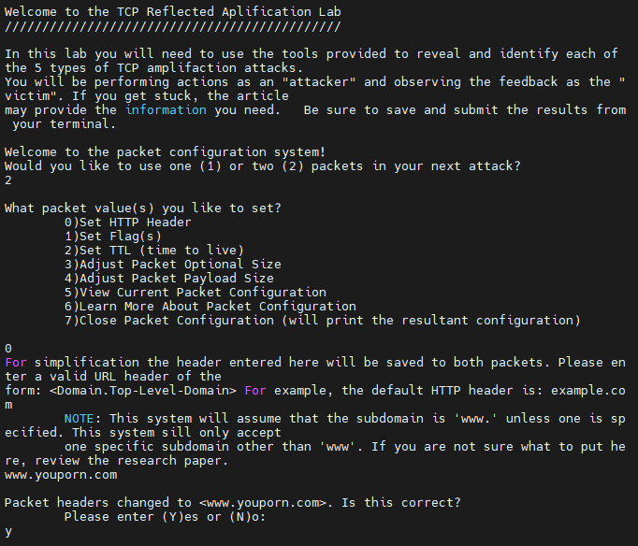

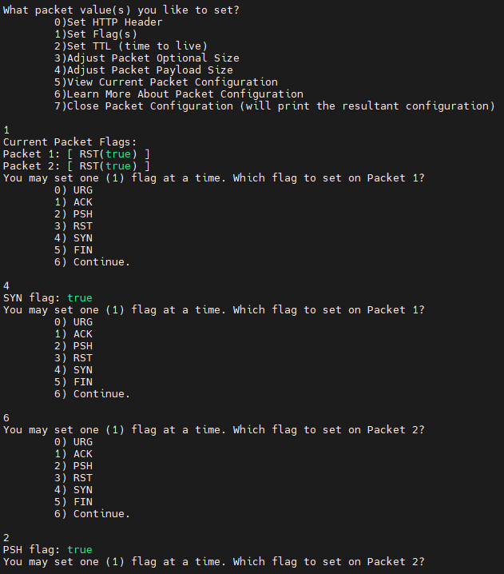
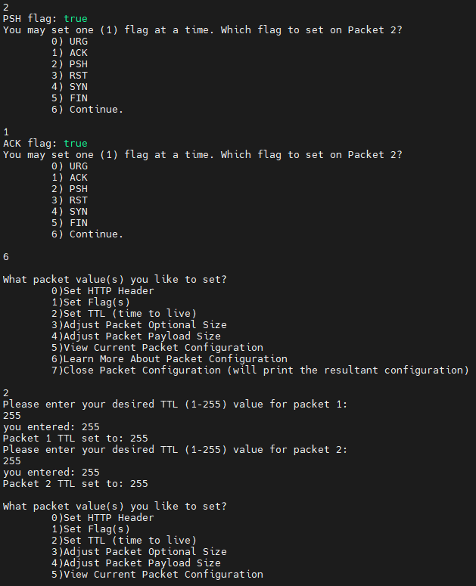

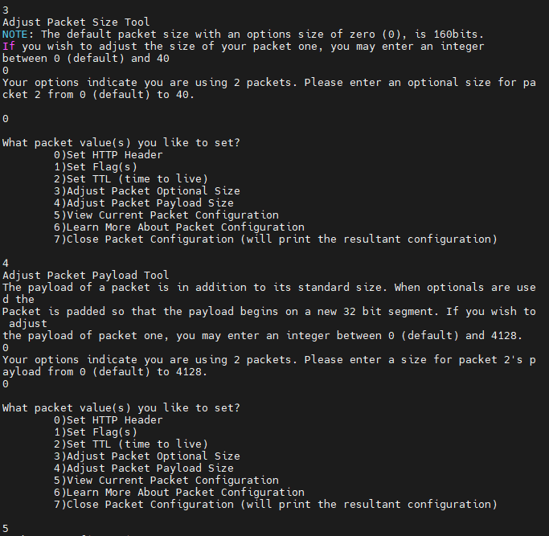
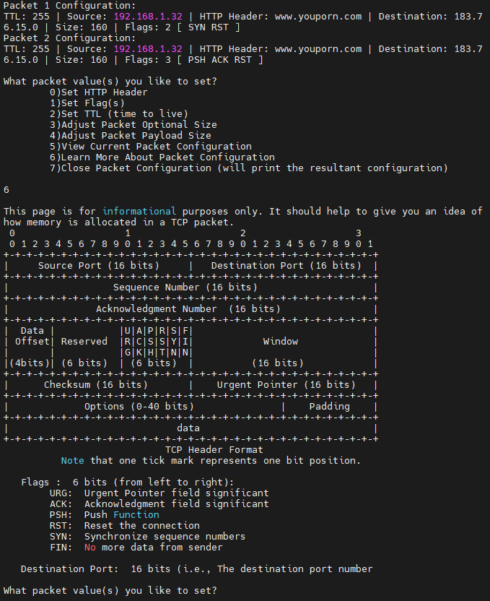
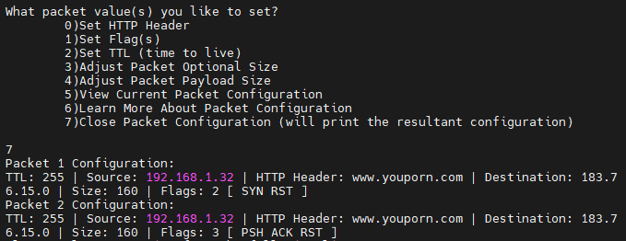
Action
2.2.1 Run the program as explained in the setup section of the lab document. Perform a wide attack, targeted attacks, and traceroutes.
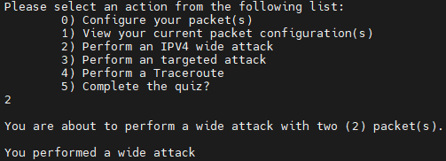

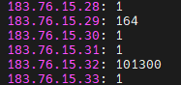

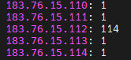

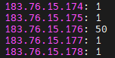

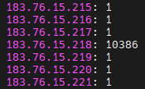

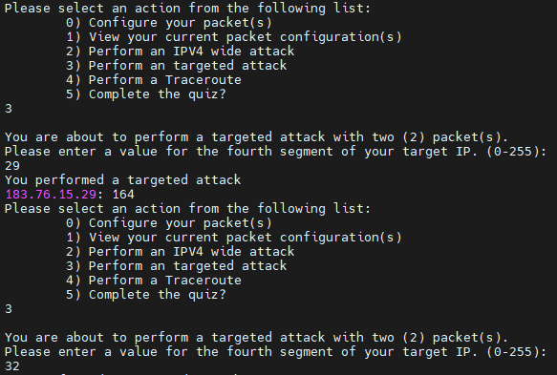

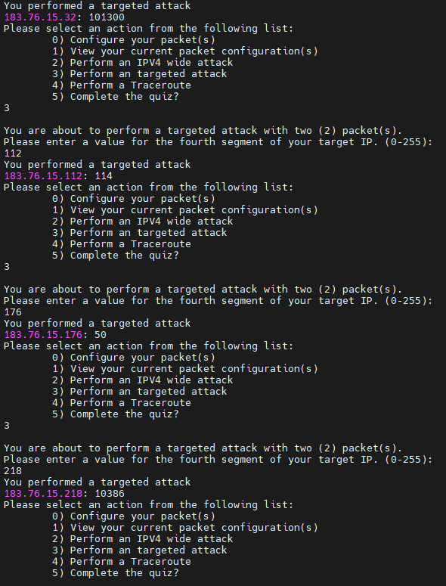
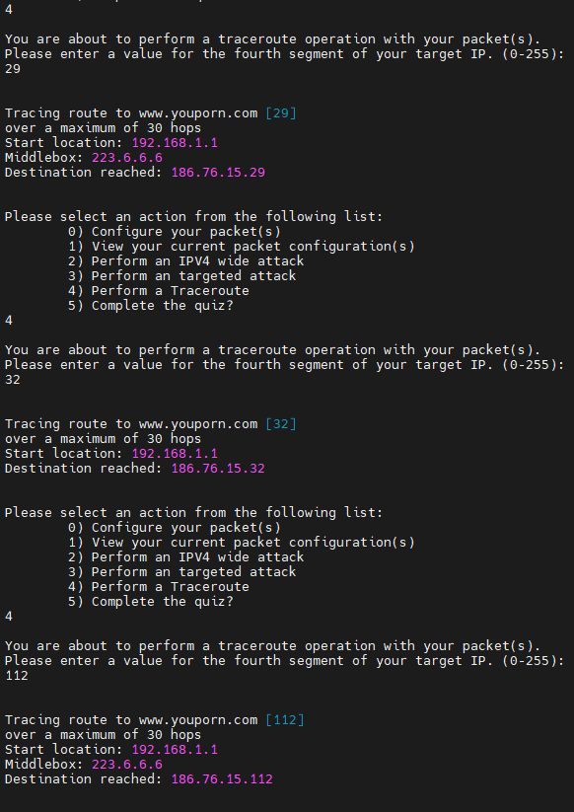

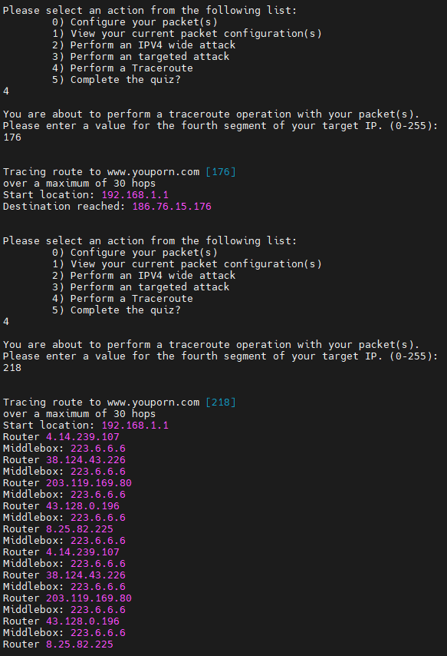
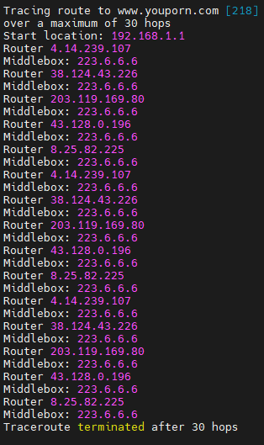
2.2.2 Complete the quiz. The IP addresses will change each time the Java program is run but the general idea remains the same. There should be 5 IP addresses that show evidence of amplification being done, each IP address corresponds to one of the amplifications presented in this lab. Using traceroute on each of the IP addresses found to show evidence of amplification when a wide attack is used, one can determine which of the amplifications each IP address shows based on the traceroute, number of packets received during wide attack, and the descriptions of each amplification type in the Overview section.
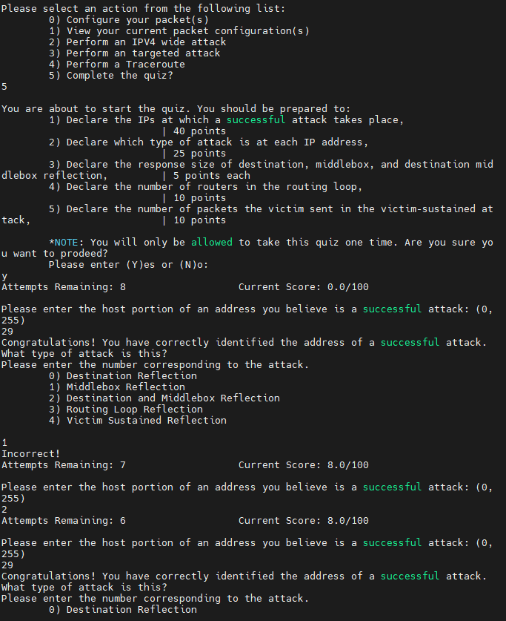

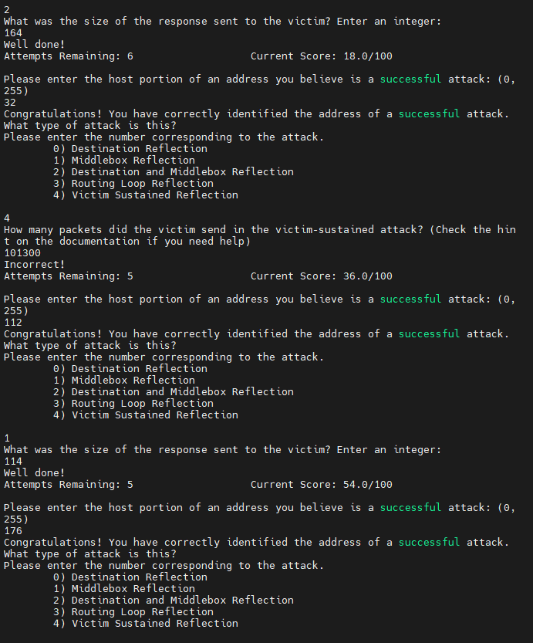

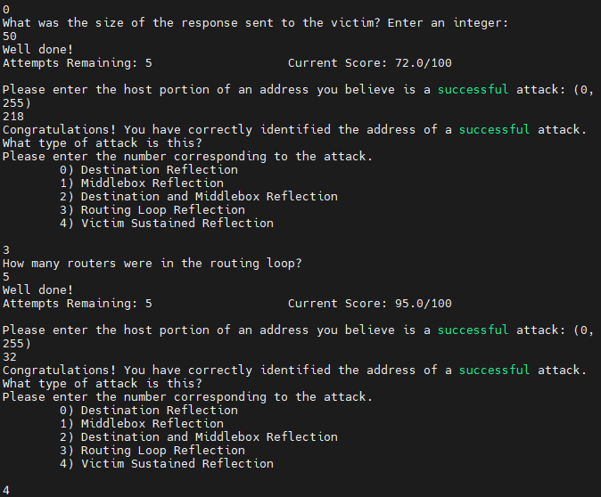

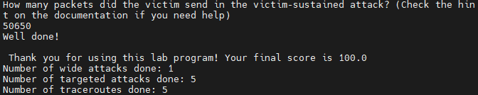

2.2.3 Save a printout of your console to be turned in along with Lab Task 1


Task Set 3
Task 3.1:
Action
3.2.1 Write your inequality.
There is a chance that the Attacker will be either a-type or b-type. P is represented with this. There are still only two options for both Attacker and Server to choose, but Server does not know what type Attacker is. Server can only see whichever table their type is while Server can see both. Server must first see what the dominant strategy is for the Attacker in each scenario. This is quite simple though as with a-type up strictly dominates Someone watching server, and as b-type Someone watching server strictly dominates No one watching server.

New: 4P + 2(1-P)
Old: 2P + 3(1-P)

4P + 2(1-P) > 2P + 3(1-P)
4P + 2 - 2P > 2P + 3 -3P
2P + 2 > -P + 3
3P + 2 > 3
3P > 1
P > 1/3

So when P is greater than 1/3 Server should play New Attack, but when it is less than 1/3 they should play Old Attack.

3.2.2 Answer the following questions.

Which attack should you use if there is a 1/2 chance the server is owned by country one?

I should use the New Attack because 1/2 is greater than 1/3.

Which attack should you use if there is a 1/3 chance the server is owned by country one?

I should use the Old Attack because 1/3 is not greater than 1/3.

Which attack should you use if there is a 1/4 chance the server is owned by country one?

I should use the Old Attack because 1/4 is not greater than 1/3.

